DELIVERABLE 1: PLANNING & RESEARCH
PROJECT PLAN & TIMELINE
WEEK | TYPE OF WORK | DELIVERABLE SUBMISSION
1 | Create project proposal | 13/01/26
2 | Create Deliverable 1: Planning & Research  Start developing concepts of website | 19/01/26
3 | Begin creating the basics of the website eg. Home page, Wishlist page, Sell page (maybe)
4 | Start creating the layout in these pages. Grid-like layout when showcasing collections
5 | Create assets for the website eg. Any menu icons, logos etc.. Add images that showcase what each vinyl is
READING WEEK | Continue or catch up on any work
6 | Complete Deliverable 2  Create a ranking system of most liked to least liked, maybe add a filter so it can display it that way too | 23/02/26
7 | Add in thoughts section for each vinyl
8 | Add in an album preview of each vinyl, so users have the ability to listen to a snippet
9 | Start adding in Spotify Web API so it can recommend music based off of my collection
10 | Add in the ability for other users to submit their own playlist to get recommended songs based off of their own
EASTER BREAK | Continue or catch up on any work
11 | Complete Deliverable 3  Polish up on the website, make final changes | 13/04/26
12 | Submit final project | 21/04/26

AVAILABLE TIME
Anywhere from 9 – 5 Monday to Friday, maybe an hour or two during weekends depending on my work schedule. Using the college computers to work on this project. GitHub for my repo, Photoshop for any art assets I want to add in and VS Code to code up the website in svelte.
PERSONAL SKILL LEVEL
I can get the basics of a website down, getting the layout down and adding images will be no problem. Having interactable menus may not be an issue either with the layout I am going for. Adding in music previews and a ranking system won’t be an issue. Spotify Web API is a new area to me so I may have issues figuring that out.
TARGET AUDIENCE & INTENDED PLATFORM
The website is for people who are interested in vinyl collecting or find a lot of enjoyment in listening to music.
I plan on creating this website using svelte, creating and customising web pages is very simple. (JS & CSS)
Similar website that I visit a lot would be Golden Discs, https://goldendiscs.ie/collections/vinyl, mine would be sort of similar minus the side menu, and the price/add to cart info displayed.
PROPOSED OUTLINE SITE MAP (BASIC) & MOODBOARD
Basic site map below, could be updated as I make progress on the site.
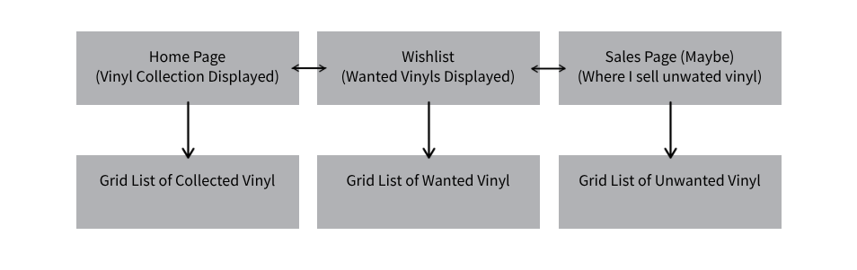
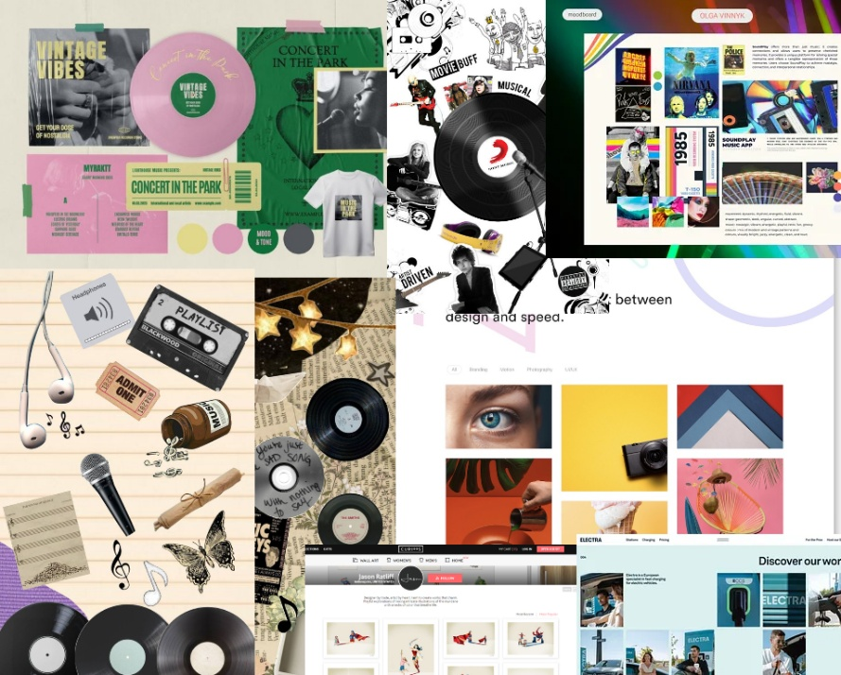
The kinda vibe I want to go for with my website; keep the layout simple and modern but try make it colourful and unique in small ways, like maybe small icons of music/vinyl scattered around in the background etc.

